**Event Report of Club/Committee Debate Club DC001**

|  |  |
| --- | --- |
| **Name of the Club** | Debate Club |
| **Name of the Event** | One Nation One Election |
| **Student Vertical** | General |
| **Instalment** | 1 |
| **Date and Time of the Event** | 21st Feb 2026, 4 PM |
| **Mode of the Event** | Offline, Venue: 1002 |
| **No. of Participants** | 80-100 (Students and Faculty) |
| **Duration of Event** | 2 hours |
| **Name of Guests** | None |
| **Designation of Guests** | None |
| **Nature of Guest** | None |
| **Event Category** | Debate |
| **Event organized in collaboration with** | None |
| **Resource person details if any** | None |
| **Achievements & Highlights** | Successful discussion on the topic, active participation from students |

|  |  |  |  |
| --- | --- | --- | --- |
| **S.No.** | **Program Outcome** | **Rating (0-3)** | **Remarks** |
| 1 | Engineering knowledge: Apply the knowledge of mathematics, science, engineering fundamentals, and an engineering specialization to the solution of complex engineering problems | 2 | Good application of general knowledge |
| 2 | Problem analysis: Identify, formulate, review research literature, and analyze complex engineering problems reaching substantiated conclusions using first principles of mathematics, natural sciences, and engineering sciences | 2 | Students showed good analytical skills |
| 3 | Design/development of solutions: Design solutions for complex engineering problems and design system components or processes that meet the specified needs with appropriate consideration for the public health and safety, and the cultural, societal, and environmental considerations | 1 | Limited design aspects in the debate |
| 4 | Investigation of complex problems: Investigate, analyze, and interpret data to inform the judgments on complex engineering problems | 2 | Good investigation of the topic |
| 5 | Modern tool usage: Create, select, and apply appropriate techniques, resources, and modern engineering and IT tools, including prediction and modeling to complex engineering activities with an understanding of the limitations | 1 | Limited use of modern tools |
| 6 | The engineer and society: Apply reasoning informed by the contextual knowledge to assess societal, health, safety, legal, and cultural issues and the consequent responsibilities relevant to the professional engineering practice | 2 | Good consideration of societal aspects |
| 7 | Environment and sustainability: Apply reasoning informed by the contextual knowledge to assess the environmental and sustainability issues and the consequent responsibilities relevant to the professional engineering practice | 2 | Good consideration of environmental aspects |
| 8 | Ethics: Apply ethical principles and commit to professional ethics, responsibilities, and norms of the engineering practice | 2 | Good adherence to ethics |
| 9 | Individual and team work: Function effectively as an individual, and as a member or leader in diverse teams, and in multidisciplinary settings | 2 | Good teamwork and individual participation |
| 10 | Communication: Communicate effectively on complex engineering activities with the engineering community and with society at large, such as, being able to comprehend and write effective reports and design documentation, make effective presentations, and give and receive clear instructions | 2 | Good communication skills |
| 11 | Project management and finance: Demonstrate knowledge and understanding of the engineering and management principles and apply these to one’s own work, as a member and leader in a team, to manage projects and in multidisciplinary environments | 1 | Limited project management aspects |

## GEO-Tagged Photograph Section

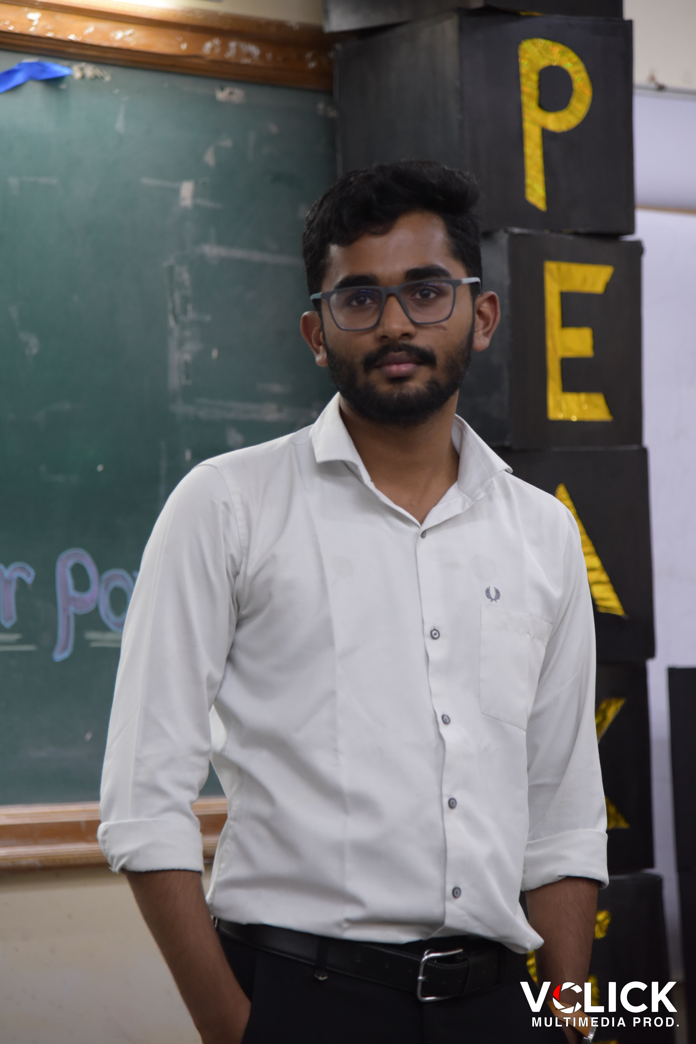

Image: Speakers_edge_-79.jpg

* Photo 1: Group photo of participants in front of the venue
* Photo 2: Speaker presenting their argument
* Photo 3: Audience engaged in the discussion

## Non GEO-Tagged Photograph Section

* Photo 1: Debate in progress
* Photo 2: Participants taking notes
* Photo 3: Moderator facilitating the discussion

|  |  |
| --- | --- |
| **Additional Details** | The event was well-organized and received positive feedback from participants |
| **Future Plans** | To conduct more debates on relevant topics |

|  |  |
| --- | --- |
| **Feedback** | Participants appreciated the opportunity to engage in a debate on a relevant topic |
| **Suggestions** | To provide more time for preparation and to invite external speakers to share their expertise |

________________________________________________________________________________

Generated by CampusOps Event Report Generator  
Date: March 01, 2026 at 10:19 AM